TOWARDS A EUROPEAN ATLAS OF LITERATURE: DEVELOPING THEORIES, METHODS, AND TOOLS IN THE FIELD OF „LITERARY GEOGRAPHY“

Barbara Piatti, Lorenz Hurni
Institute of Cartography
Swiss Federal Institute of Technology (ETH)
CH-8093 Zurich, Switzerland
bpiatti@ethz.ch, hurni@karto.baug.ethz.ch

Literary Geography
Literary geography or the Geography of Literature is, according to Brian Stableford, „a fugitive field“, moreover a research field so far only established in its rudiments. It all starts with a surprisingly simple question: Where is fiction set? Under the terms of literary theory a fictional or narrated world is made of three components: characters (1), plot/timeline (2), and space (3). While characters and plot have been and are subject to countless philological studies, the topic of space and place in literature is rather neglected. Literary geography pushes it form the margins into the center of attention. The basic question „Where is the setting of fiction?“ leads quickly to the conclusion, that each literary work takes place somewhere, along a scale of localization that ranges from the completely imaginary to the realistically rendered, highly recognizable and easily placed. Hence the main focus of a literary geography is laid on the manifold interactions between real and imaginary geography in various literary genres. A first example:

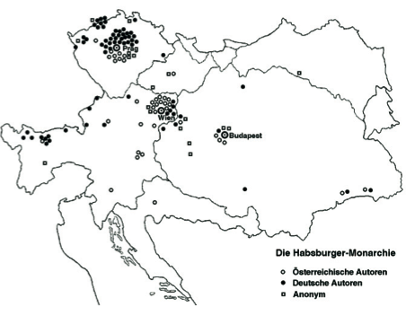Fig. 1: The Geography of historical novels within the
borders of the Austrian-Hungarian Empire 1780 – 1850

What becomes instantly visible in this figure is the distribution of action in historical novels from 1780 up to 1850. Most of the novels do play in the cities, in Prague, Budapest, Vienna, only a minor few in the provinces and at the peripheries. At first sight, you realize that one of the major contribution of literary geography is to rend visibility to „overcrowded areas“ and „unwritten regions“ within the literary metaspace.

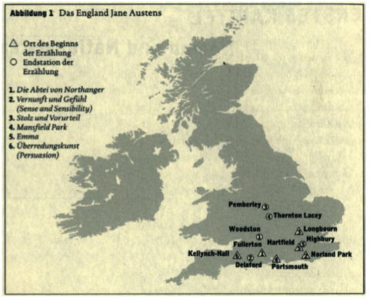 Fig. 2: The Geography of Jane Austens novels

Fig. 2 is taken from Franco Morettis Atlas of the European Novel (1998), until now the most ambitious attempt in literary geography. What is on display is a map of some of Jane Austens most famous novels (like Sense and Sensibility, Pride and Prejudice); Moretti mapped the places, where the narration does start, and those where the plot comes to a happy or unhappy end. You see again immediately that Austen could have had a whole lot more space on her disposal – but she didn’t make use of this option. Writing her novels, she did deliberately not introduce colourful settings like London, the Lake District, or the Highlands in Scotland, and she neither turns west, to the „green Island“ Ireland, nor east, to the continental geography. Her space, which supplies her with settings for many stories is quite narrow – it embraces only the pittoresque south of England, a peaceful area with fields and meadows, mansions and little villages, which are thoughtfully arranged in Austens fictional worlds. Just think by comparison of plots with a significantly bigger geographical radius – like Herman Melvilles Moby Dick or Mary Shelleys Frankenstein, the latter with settings situated in various European countries and a show-down located in the arctic regions.
Moretti himself comments on this first map in his Atlas, that it already contains all the secrets of literary geography: You read books, focussing on spatial aspects, then you design a map – finally, you have a look at that map, and hopefully you discover things you didn’t know before: New insights which are generated by that map. This is a very important point: Literary geography should be much more than mere cartographic illustration or support to a text in which everything is already said. Quite the contrary literary maps are meant to be tools of interpretation, powerful analytical instruments developped in order to re-write literary history.
There are some precursors of literary atlases, but none of them could be called satisfying in terms of cartographic solutions and scientic output (the combination of Geography/Cartography and History of Literature dates back to the beginning of the 20th century). They all – with the exception of Moretti – remain on the rudimentary level of an illustrative literary geography.

Maps as tools in the field of literary geography
What is meant by interpretative maps, I will show you in more detail, taking as an example and model region Lake Lucerne. This overwhelmingly sublime landscape is situated in the heart of Switzerland, between Lucerne in the North and Mount Gotthard in the South. It can be said without overstatement: The lake, and the encircling valleys and mountain peaks amongst which it is artfully inlaid, is demonstrably a capital region on the map of European literature. As a geospatial totality, this region perfectly unifies the multiplicity of the Swiss landscape. There is a confluence of idyllic passages and lofty positions, attributable to the topographic situation of Lake Lucerne, in transition between midlands and high mountains. The farther south one goes in the direction of Gotthard, the more dramatic the landscape appears. The region thus contains the many particularities that make a geographic place a challenge to literature.
On Fig. 3 the geospatial section I’m talking about is clearly marked.
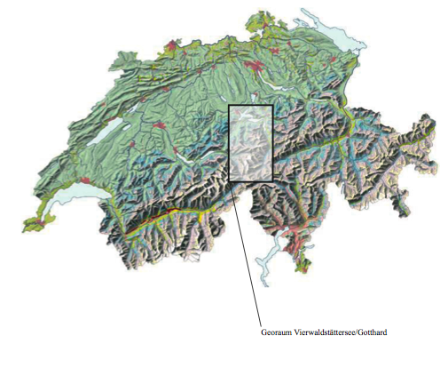 Fig. 3: Investigation area between Lucerne and Mount
Gotthard (Central Switzerland)

This portion of space is of enormously high demand as a setting for fiction.

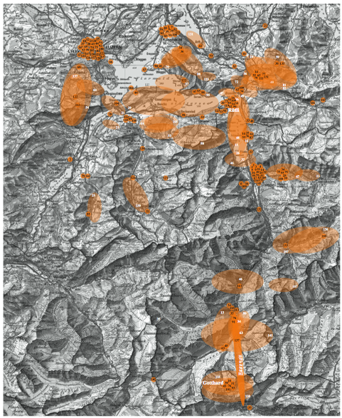 Fig. 4: The literary metaspace: settings and places of action

As a background in a variety of grey shades you see a topographical map of the region in question (fig. 4). Silhouetted in orange ellipses and single dots the so-called literary metaspace becomes visible (ellipses = settings which can be indicated vaguely, as a zone; dots = settings which can be localized precisely). The map presents settings of 150 fictional texts – novels, short stories, ballads, dramas – written and published in a timeframe between 1800 and 2005. This portion of geospace is connected with a virtually unbelievable catalog of resonant names, an international crowd of highly acclaimed writers among them Johann Wolfgang Goethe, Wilhelm Heinse, Friedrich Hölderlin, Heinrich Heine, Achim von Arnim, Friedrich Schiller, William Wordsworth, Alexandre Dumas, Sr., Alphonse Daudet, Leo Tolstoi, Fedor M. Dostojewski, Iwan Bunin, Mark Twain, Walter Scott, Mary Shelley, John Ruskin, James Fenimore Cooper, Johann Peter Hebel, D. H. Lawrence, Henry James, Samuel Butler, W. Somerset Maugham, Gustave Flaubert, Arthur Rimbaud, Jeremias Gotthelf, Gottfried Keller, August Strindberg, Hermann Hesse, Robert Walser, Carl Spitteler, Max Frisch, Elias Canetti.
What we’re able to spot immediately are the unwritten regions, covering distant valleys and mountain peaks. On the other hand we see a wealth of literature from Lucerne to Mount Gotthard, the settings lined from Northwest to South, along the famous historical road which leds to the pass. You can also discover, inside that orange space, some areas which are outstanding due to their extreme density – the lovely regions around the lake, the shores and the surface of the lake itself (there are many fictions including a steamer trip) as well as the rough and sometimes bizarre rocky landscape of Mount Gotthard. Those are zones which are particularly attractive when it comes to the choice of a setting.
Taking this map as a starting point I had a closer look at the qualities of this specific literary metaspace.

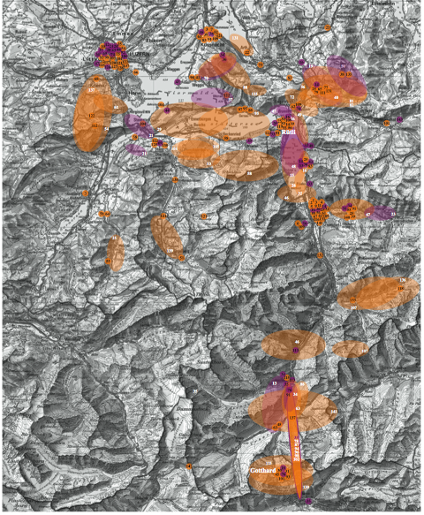 Fig. 5: Fiction written by foreign authors (marked in violet)
vs. fiction written by swiss authors (marked in orange), in
the period between 1800 and 2005

In fig. 5 all settings, belonging to fictional texts, written by a foreign author, are marked in violet, covering the decades from 1800 until 2005. In other words: Since you discover a lot of violet on this map, the literary metaspace is to be valued as a rather international one. But this won’t stay that way. In fig. 6 I only marked texts in the period from 1914 until 2005 – and suddenly you’re witnessing the extinction of a once internationally structured literary space. In the 20th century literature, at least the international one, was moving elsewhere, while the space kept some attractivness for swiss writers, most of them local ones.

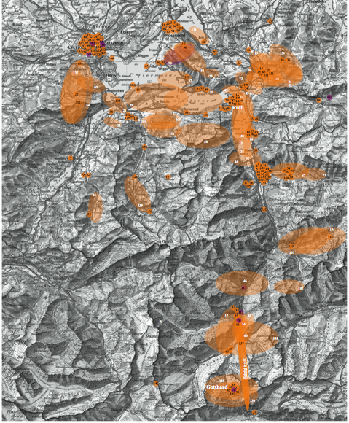 Fig. 6: Fiction written by foreign authors (marked in violet)
vs. fiction written by swiss authors (marked in orange), in
the period between 1914 and 2005

On the next map (fig. 7) those settings which stand in relation to a non-historical plot are displayed in violet. This means, that those plots could be set elsewhere – for example at another celebrated tourist site, in another mountain region. The stories could play elsewhere because they are not bound to this particular area. Let me explain more clearly: What we’re looking at is the landscape of the swiss mythological hero William Tell. There are hundreds of texts telling his story again and again, an endless line of variations. Tells story couldn’t be set elsewhere, it’s rooted in that region. But the map shows that there is, besides that one plot, a whole range of possibilities in transforming the landscpae into settings – for love and crime stories, surreal and fantastic happings, travel romances and tales of a new generation. Lake Lucerne and its breathtaking surroundings are nothing else than a giant stage for fictional plots, offering lakes, shores, valley, mountains, caves and tunnels, in total an exciting multifunctional space, just made for all kind of adventures.

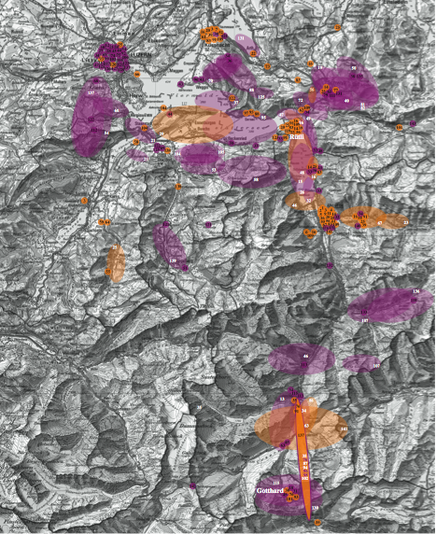 Fig. 7: Freely invented fiction (marked in violet) vs. fiction bound historically to the space in question (marked in orange)

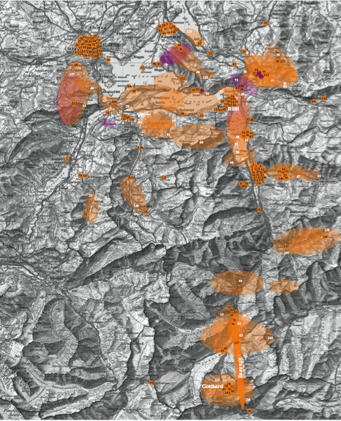 Fig. 8: Discrepancies between textual spaces and geospace (marked in violet) vs. realistically sketched settings (marked in orange)

Looking the last map (fig. 8) it probably gives you some trouble to spot the violet marks. There are indeed only a few. This time, they indicate discrepancies between textual space and geospace. In many cases writers choose for their stories settings that have a „real-world counterpart“ – and they design these settings in a rather realistic way, sometimes even that realistic that you could as well use them as a guidebook. But literature has infinite options to deal with space (which makes it apparently so hard to map it in a sensible way). Of course, a setting mustn’t be sketched realistically at all, it can be partly or completely invented, it can be a cross-fading of two spaces (like in Julio Cortázars short story All fires the fire (1966) in which the setting consists of a confusing combination of two urban topographies, namely Buenos Aires and Paris), it can be a familiar location, but disguised with an imaginary toponym (or pseudonym), or, it might even be nameless and/or only vaguely localized. However, writers who have chosen Lake Lucerne as a setting usually don’t transform it. They rather stick to the given topographical features. There are a few exceptions: Walter Scott, who sets a fictitious castle into the landscape thus combining an existing region with a newly invented element (Anne of Geierstein, 1829); or Carl Spitteler synthesizing Mount Rigi, a world-famous outlook, with Mount Olympus thus creating a new space with only faint correspondences to the existing geospace (Olympischer Frühling, 1900 – 1905). But the message of this last map is another one: The majority of writers don’t feel to change the given geospace. It offers, as said above, enough possibilities to place characters and let them move around.

Towards a Literary Atlas of Europe
After having commented on a couple of maps, think now of the horizon which opens if these methods are transferred to a larger, more precisely: to a European scale. And think of the possibilities interactive maps and animations could add to the static cartographic representations shown so far.
By actually mapping fictional spaces and places a broad range of questions is going to be dealt with for the first time: Why are some landscapes overly covered by literature while others remain blank spots? Why are some areas of high interest to internationally acclaimed authors while others seem to have a certain appeal to regional writers only? What happens in times of war – does the space of literature shrink or widen? Are there any typical plots requiring imaginary settings rather than realistic ones? What comes in sight is Europe’s (imaginary) space of literature, which has its own dimensions, functions according to its own rules, but which is nevertheless anchored in the „reality“ of existing spaces and places.
The explicit goal is to rend visibility to the specific geography of literature. In order to design such an atlas, new tools and techniques are required. The central instrument for the exploration of literary geography has two components: a database of texts and a cartographic visualization which grows out of this database.
The database contains texts ranging from regional to world literature with appropriate thematic, temporal and geographic attributes („metadata“). The first step is quantitative, since for each model region several hundred texts are registered. In the next step, precise queries can be directed to the database: Where is the historical novel staged in the nineteenth century? When does the fictionalizing process begin for a certain region? Where are there historically saturated zones, which lend themselves to historializing accounts, and where are there history-free zones?
The results are shown as maps, tables, or diagrams, but the maps generated are not merely statistical. Through the combination of the database and cartographic renderings, fictional spaces become visible. The newly generated map material thus allows a much more exact, closer description of a fictionalized space and its genesis than previously. In a final phase, literary historians interpret and comment on the cartographic .
Within the scope of our project „A Literary Atlas of Europe“ (www.atlas-of-literature.eu), the potential of such maps will be demonstrated in the example of three differently endowed model regions: a sublime Alpine landscape (Lake Lucerne/Gotthard in Switzerland), a coastal border area, an amphibian landscape between water and land (North Friesland in Germany), and an multilayered urban space, a hot spot of world literature (Prague, Czech Republic). The literary permeation of these three spaces is examined within a time frame of about 250 years, from ca.1750 to the present.
In the interactive version of the atlas, the geography of a single author, a group of writers, or a particular literary-historical epoch can be called up, as well as the literary geography of a minority or of an entire nation. One could ask: Are there epoch-specific settings? Is there a typical Sturm und Drang landscape, a landscape of Romanticism, is there a site of expressionism? Some questions could even be asked for the first time: are there works or types of works that are specifically set in imaginary places, and others that are better suited for referential settings?
In all, what emerges is the European metaspace of literature, which has its own dimensions and functions according to its own laws, but which nevertheless corresponds with and stands in mutually dependant relation to really existing areas and places. In the process, not only are the literary riches of single regions illuminated, but also, fictionalized landscapes and cities in all of Europe can be examined comparatively, in the sense of a literary-geographical system. In the end the literary atlas project can be described as a spatially and no longer chronologically organized history of Europe’s literary heritage and ongoing production – a way of re-writing the history of literature.

List of illustrations/ picture credits

Fig. 1 „The Geography of historical novels within the borders of the Austrian-Hungarian Empire 1780 – 1850“ (= Landkarte:
Handlungsorte in der Habsburger Monarchie 1780 – 1850 (1995). In: Habitzel, Robert et al.: Habsburgische Landschaften
im historischen Roman vor 1850. In: Die habsburgischen Landschaften in der österreichischen Literatur. Beiträge des 11.
Polnisch-Österreichischen Germanistentreffens Warschau 1994. Hrsg. von Stefan H. Kaszinski et al. Poznan: Univwersytet im. Adama Mickiewicza 1995, p. 23 – 56 [source: http://histrom.literature.at/docs/habsburg.html, 26. 05. 2007].

Fig. 2 „The Geography of Jane Austens novels“. In: Moretti, Franco: Atlas des europäischen Romans. Wo die Literatur spielte.
Köln: DuMont 1999, p. 24.

Fig. 3 „Investigation area between Lucerne and Mount Gotthard (Central Switzerland)“, graphic design: © by the authors.

Fig. 4 „The literary metaspace: settings and places of action“ based on a topographical map of Lake Lucerne/Gotthard
(scale 1: 25'000); graphic design: © by the authors, geodata provided by Federal Office of Topography swisstopo,
CH-3084 Wabern, Switzerland.

Fig. 5 „Fiction written by foreign vs. fiction written by swiss authors, in the period between 1800 and 2005“ based on a topographical map of Lake Lucerne/Gotthard (scale 1: 25'000); graphic design: © by the authors, geodata provided by Federal Office of Topography swisstopo, CH-3084 Wabern, Switzerland.

Fig. 6 „Fiction written by foreign vs. fiction written by swiss authors, in the period between 1914 and 2005“ based on a topographical map of Lake Lucerne/Gotthard (scale 1: 25'000); graphic design: © by the authors, geodata provided by Federal Office of Topography swisstopo, CH-3084 Wabern, Switzerland.

Fig. 7 „Freely invented fiction vs. fiction bound historically to the space in question“, based on a topographical map of Lake
Lucerne/Gotthard (scale 1: 25'000); graphic design: © by the authors, geodata provided by Federal Office of Topography
swisstopo, CH-3084 Wabern, Switzerland.

Fig. 8 „Discrepancies between textual spaces and geospace vs. realistically sketched settings“, based on a topographical map of Lake Lucerne/Gotthard (scale 1: 25'000); graphic design: © by the authors, geodata provided by Federal Office of Topography swisstopo, CH-3084 Wabern, Switzerland.

Stableford, Brian: Introduction. In: Cyclopedia of Literary Places, vol. 1, Pasadena (CA): Salem Press 2003, p. xxxv.
Moretti, Franco: Atlas of the European Novel, 1800 – 1900. New York/London: Verso 1998.
See for example: Nagel, Siegfried Robert: Deutscher Literaturatlas. Die geographische und politische Verteilung der deutschen Dichtung in ihrer Entwicklung nebst einem Anhang von Lebenskarten der bedeutendsten Dichter. Wien: Fromme 1907; Schlosser, Horst-Dieter: dtv-Atlas zur deutschen Literatur. Tafeln und Texte. München: Deutscher Taschenbuch Verlag 1983; Sharp, William: Literary Geography. London: Pall Mall Publications 1904; Bradbury, Malcolm (ed.): The Atlas of Literature. London: De Agostini Editions 1996; Ferré, André: Géographie littéraire. Paris: Editions du Sagittaire 1946.

